**Project Proposal**

**An Intelligent Travel Guide**

**Submitted By:**

**Shaon Kanti Dhar**

Roll: ASH1511025M

**Project Supervisor:**

**Tanvir Zaman Khan**

Lecturer

Information and Communication Engineering



NOAKHALI SCIENCE AND TECHNOLOGY UNIVERSITY

Noakhali-3814, Bangladesh

Submission Date: 17 December, 2018

1

**DECLARATION**

This project proposal is submitted to the Information and Communication Engineering, Noakhali Science and Technology University, Noakhali for having the B.Sc. in Engg. Degree in ICE. This is also needed to certify that this project is under the B.Sc. in Engg. Course of dept. Of ICE, NSTU titled “ICE-4110: Project and Thesis”. So, I, here by, declare that this project report has not been submitted elsewhere for the requirement of any kind of degree, diploma or publication.

Shaon Kanti Dhar

B.Sc. Student of ICE, NSTU

Roll No: ASH1511025M

Session: 2014 - 2015

2

**ACCEPTANCE**

This project proposal is submitted to the Information and Communication Engineering, Noakhali Science and Technology University, Noakhali.

(Tanvir Zaman Khan)

Lecturer

Information and Communication Engineering

Noakhali Science and Technology University

Sonapur - 3814, Bangladesh

3

**ABSTRACT**

Travelling is a source of refreshment. It refreshes our mind and help us to meet the nature and visit beautiful places. Many people enjoy capturing the visual contexts that describes the places where they have made a trip. There are less opportunity to share this experience. Thus it reduces the quality of the narrative experience that they receive when they want to visit a place. To facilitate the narrativization of a tourist place and create a shared experience of that place, here I proposed a system in which the people can share his/her experience through some description, captured pictures and rating of the visited places securely. Often it is seen that every year a larger number of foreigner from diverse countries come to visit the most popular spots of our country. However, being foreigners, they face different types of problem including the limited information of nearby hotels, restaurants and hospitals for emergency services. Based on these requirement this project will provide the detail information of the visited place including the nearby hotels, restaurants and hospitals. This project will also provide a city map depending on current location of the traveler to exhibit how to reach the destination place within short time by avoiding traffic jam. Apart these feature this project will provide another feature of weather forecast of the last couple of days. As we know Bangladesh is prone to natural calamities, people who wish to visit Bangladesh can get weather forecast information of the cities from this project. Basically this project is beneficial for the tourists having not so much idea about the places they want to visit. The ultimate goal of this project is to provide a better guide to the travelers of how to enjoy the travel.

4

**TABLE OF CONTENTS**

|  |  |  |
| --- | --- | --- |
| **Serial No.** | **Name of The Topic** | **Page No.** |
|  |  |  |
| 1. | Introduction | 6-7 |
|  |  |  |
| 2. | Literature Review | 8-9 |
|  |  |  |
| 3. | Objectives | 10 |
|  |  |  |
| 4. | Design Methodology | 11-15 |
|  |  |  |
| 5. | Project Requirements | 16 |
|  |  |  |
| 6. | Design Prototype | 17 |
|  |  |  |
| 7. | Conclusion and Future Works | 18 |
|  |  |  |
| 8. | References | 19 |
|  |  |  |

5

**1. INTRODUCTION**

Bangladesh is a land of scenic beauty which attracts the tourists. She has beautiful beaches as well as the longest beach in the world. It is proud of her beautiful heritage and historical relics. People get refreshment and enjoyment from these beauties. Some People have curiosity to visit the unknown places. So, they need to know about how to go the destination places, the availability of nearby hotels, restaurants and hospitals and also the weather condition of the places. But the problem is, these information are distributed disjointly in many applications. Sometimes it is seen that the tourists get sick in their visited place and need to take emergencies. Therefore, this project is proposed to offer a system for helping them by providing the collective information of routing, nearby hotels, nearby restaurants and nearby hospitals for emergency services.

We know that the Location Based Services (LBS), which answer the location-related queries provides many advantages. Google APIs are one of them. It includes Google Places API, Google Map API, and Google Places Photos API etc. that has some promising applications like local information obtain (traffic condition, navigation messages and so on) and neighboring environment queries, such as finding the nearest restaurant. However, the problem is, there is no such application that use these APIs in a clustered form. As we can use these APIs freely so by integrating those together in an application will result in a complete guide for the travelers. Therefore, this proposed project will use most of the functionality of these Google APIs to seize all information about the specific location collectively. The usage of these APIs will reduce the time required to search for a place and to know about a place. These will also lead to quicker decision making with respect to places to visit.

Sometimes people enjoy capturing the place in pictures as their memory while they are visiting a place. They usually gather many experience after visiting a tourist place. But there are less opportunity to share this experience. In this proposed project there will be a community feature for them so that they can share his/her experience and can be benefited in various aspects. Basically in this community, a traveler can be able to share his/her feelings related to the visited places through some description and rating of the places out of five. This rating will indicate how well the place according to the user’s interest. This will assist the travelers to get realistic information about any touring places. Additionally, in this project a user can be allowed to

6

share the pictures of touring places that they have visited recently. This pictures will be verified by using Image Processing with Google Place Photos to detect whether these are the real ones according to the exact places. Also the pictures which are related to the sensitivity will also be avoided by using Microsoft Sensitive Content Detection. This will make the system more secure.

Often it is seen that every year a large number of foreigners from diverse countries come to visit the most popular spots of our country. Some of them are: Chittagong – Gateway to the Bay of Bengal; Cox’s Bazar – The Tourist Capital; Rangamati – The Heart of the Lake District; Kaptai – The Lake Town; Sylhet – Land of Two Leaves and a Bud; Sundarban – Home of the Royal Bengal Tiger; Bandarban – The Hilly Resort; Kuakata – Where the Sun Rises and Sets in the Sea; Mainamati – Seat of Lost Dynasties; Mahasthangarh – The Ancient Seat of Buddhist Rule; Paharpur – The Seat of Buddhist Learning; and Mymensingh – The Heart of Bengal’s Folklore etc. The following figure shows the result of a survey of tourist spots of Bangladesh visited by travelers that described in **[13]**, where Cox’s Bazar is found to take the first position by 73.3% foreigner.

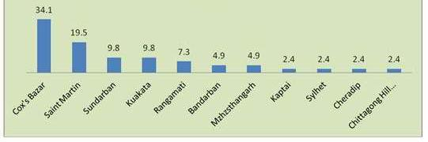

**Figure 1: A survey of the tourist spots of Bangladesh visited by traveler**

This proposed project will be served as a guidance to those travelers by providing a geographic based information system so that they can visit all these places comfortably. Also it will suggest them to visit the nearby other touring places. It may have a positive impact on them to visit more and more places to discover something.

7

**2. LITERATURE REVIEW**

Bangladesh is full of nature, beauties and most of attractive places. People get refreshment and enjoyment from these beauties. When people get free time they want to be adventurous, visit different places. Some people are wants to visit unknown places. So they need to know about how to go the destination places, the location directions. The Location based Services that described in **[1]** offer many advantages to the mobile users to retrieve the information about their current location and process that data to get more useful information near to their location such as current traffic conditions, routing information, finding nearby hotels etc. Based on this many applications are developed related to travel guide that basically provides city map with detailed information depending on user’s current location **[2]**.

It is seen that there are some applications are developed that just provides community feature among the travelers, such an application are described in **[3]**. But this is not enough for the travelers. Sometimes they may need to know more detail about the places they are going to visit. Though it is not necessary for historical places or common places as we can have information about them through newspaper and magazines, but it becomes exigency to know when they plan to visit some uncommon places. Though some application like **[4]** provides the static information of natural beauty of the touring places but sometime it seems like an unrealistic information. My project will provide a user rating system of touring places that implies after visiting a place a user can be able to share his/her feelings through some description as well as a rating of the place. This rating will indicate how well the place according to the user’s interest. This will assist the travelers to get realistic information about any touring places so that they can easily plan to travel places without any illusion. Additionally, in my project a user can also be able to share the pictures of touring places where they have made a trip. Though this feature has developed in many applications such as **[3]** but the pictures uploaded by the user are not verified according to the exact places. A user can share fake pictures in the existing system **[3].** My project will overcome this limitation by using image processing with google places photos **[5]** to detect whether the pictures are the real ones. It will also avoid sensitive contents by using Microsoft sensitive content detection **[6]**.

8

Usually, in a variety of factual situations some traveler wants to plan his/her trip with lower cost while the other wants to have suitable accommodation services. There exists many application or system that provides routing information, cost and accommodation services but not clusterly. For example, the system which is described in **[1]** imparts the information of routing and accommodation services but doesn’t inform the estimated cost to visit the places. My project will have all these services for the travelers to make their travelling comfortable. It will also uphold the nearby hospitals for emergencies. Mainly, by providing a geographic based information system the tourists and people shifting to new cities can get a better guidance of the places they want to visit. It includes many advantages as the user can view the required location in map and accordingly estimate the time will be required to reach the final destination. By using this project a user can be able to inspect the nearby touring places through google map depending on his/her current location and also it will suggest them to visit places according to his/her interest. One of the most interesting feature of my project is that if a blind man uses this application, then he/she will get listening the voice of the related content by text recognition

1. which isn’t present in any existing system regarding to travel guide.

9

**3. OBJECTIVES**

We know Bangladesh is a land of natural beauty. She has a delicate and distinctive attraction of its own to offer. But it is a matter of sorrow that she is one of the few countries in South Asia which remains to be explored. As we are now living in the era of information and internet and large number of people use smart phone, so it’s our responsibility to introduce a system for them that will uphold the tourist’s places of our country and also provide a better guide of how to visit these places securely. This will enhance the curiosity among travelers as well as the number of travelers visiting in our country. Basically this project is proposed to offer such a system with some vital objectives that may be useful for the travelers. Some of these are given below:

* To provide information of the nearby hospitals, restaurants and hotels.
* To offer a facility through which the people can share his/her travelling experience.
* To assist the blind people by allowing them to know about the natural beauties of our country through the user's shared experience.
* To reduce the time required to reach a place through visualizing the traffic condition of cities.
* To give an idea of the weather condition before making a plan to trip.

10

**4. DESIGN METHODOLOGY**

The architecture of this system can be divided into several parts based on its features where each part will perform some specific tasks. Some of the major parts are –

* Sharing the experience of user’s travel
* Getting google place images and compare them with user’s selected image
* Sensitive content detection
* Database module
* Exploring the nearby spots
* Text recognition

Here I will describe these major parts of my project briefly.

**Sharing the experience of user’s travel:**

When a user will log into my system then he/she can be able to see a page called “Home Page” which will contain user's shared experience of their traveled places. A user can add a picture of his/her visited places by pressing a button in the home page. Then he/she will have to add some description, location and finally rating of the traveled places. The user can also share this post with their friends by tagging them. Basically, in that simple way a user can share his/her travelling experience. The following diagram shows this process.

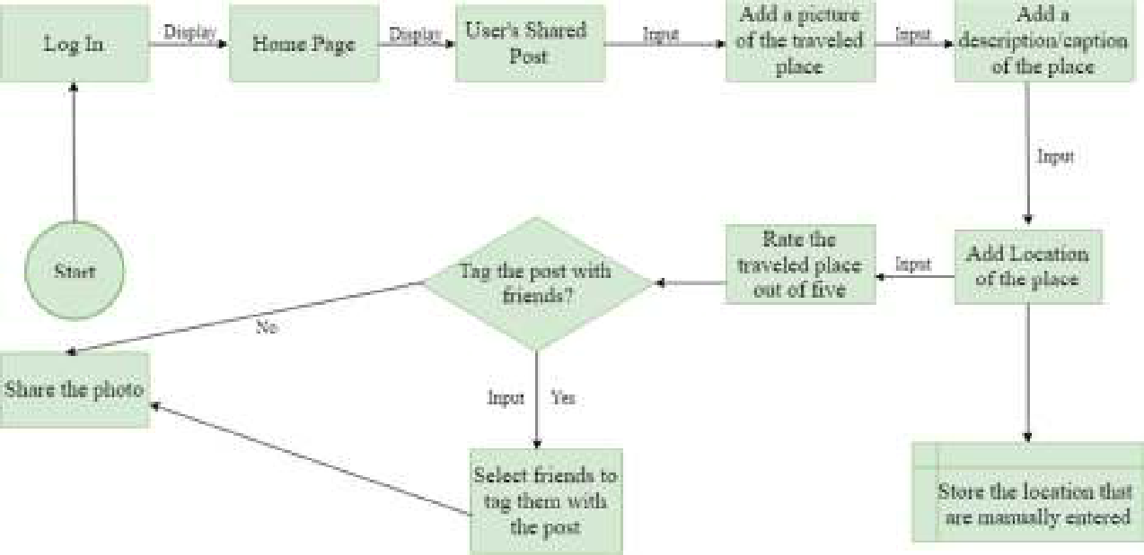

**Figure 2: Block diagram of sharing user’s travelling experience**

11

**Getting Google Place Images and Comparing them with user’s selected picture:**

When the user wants to share a post with the picture and rating of a specific location like the above figure 2, then the location will be converted into the Google Places Name Via Google Geo-coding API **[8]**. This is an important part of getting Google Place Images because by using Google Places Name we can get accurate pair of latitude and longitude than using the manually entered location by the user. After getting the Google Places Name of that location, the next step is to get the latitude and longitude which will be used to get the Google Place Images of that location. Finally, a comparison will be made to ensure whether the image that are selected by the user are the real ones of the exact place. The following diagram shows this process with more simplification.

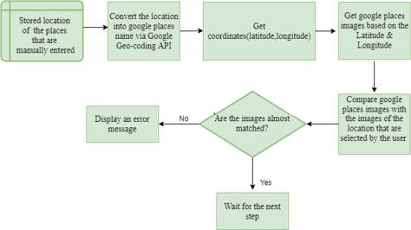

**Figure 3: Block diagram of Comparing google place images with user’s selected image**

12

**Sensitive Content Detection:**

After making a comparison if the image are almost matched then it will be tested for sensitivity detection. In my project the sensitivity will be detected by analyzing the image. The Analyze Image Method will return two properties, ‘isSensitiveContent’ and ‘isRacyContent’. After analyzing the image these two properties will return a probability which will be used to perform a comparison to decide whether the image contains any sensitive content or not. The following diagram shows the sensitivity detection process.

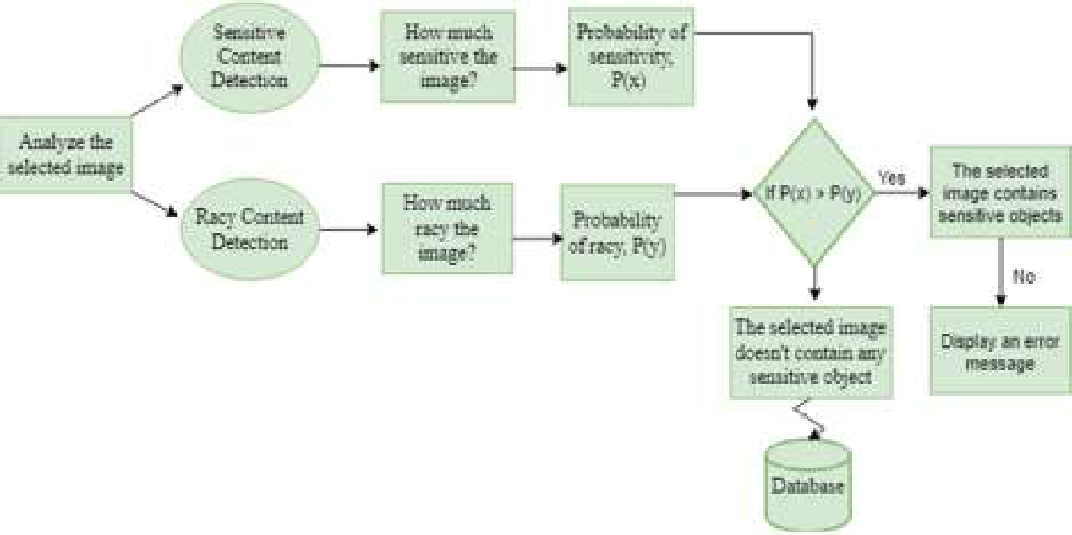

**Figure 4: Block Diagram of Sensitivity Content Detection**

**Database Module:**

After analyzing the image if it is found that the image has no sensitive content then the image and other information will be stored in database. Though there will be many table in the database but these data will be stored only in a table called ‘User Photos’. The ‘User Photos’ table can have many attributes. Each user will be identified by a Unique ID to detect which photos belongs to whom. Finally getting the data stored in the table will be shown to the ‘Home Page’. The following diagram shows a simplified version of the table.

13

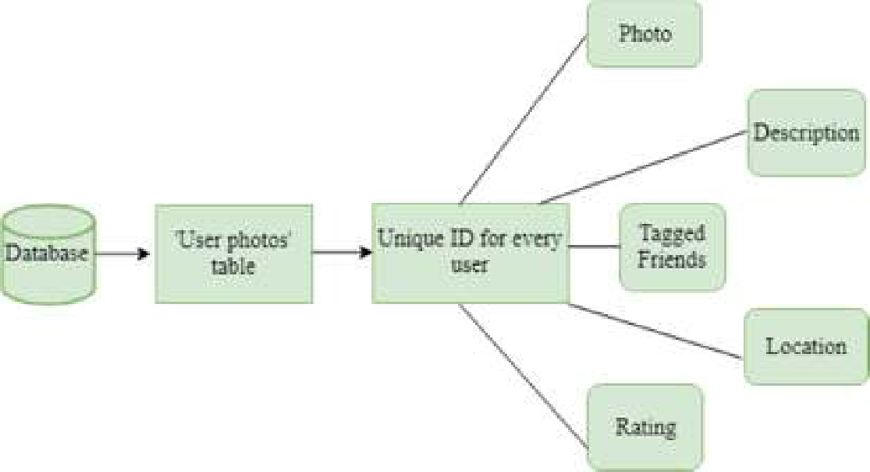

**Figure 5: ‘User Photos’ table attributes**

**Exploring the nearby spots:**

The most important part of my project is to help the user by providing information about the nearby hospitals, nearby restaurants, nearby hotels and nearby touring places while they are on a trip. In my project this feature will be developed by following several steps. Basically when a user will search for his/her nearby spots, the first step will be the getting of location of the user. Based on this location the latitude and longitude will be seized. Then using ‘Google Places API’ **[9]** and those latitude and longitude we will get the different types of spots that will refer the different types of nearby spots. Basically the ‘Google Places API’ has a property that called ‘types’ which indicates the types of the places that means whether it is a hospital or restaurant or hotel or attraction place. Finally, all these information will be shown into the google map when the user will search for nearby spots. Also the weather condition of the user’s location will be shown by using ‘OpenWeatherMap API’ **[10]**. The following diagram shows a brief overview of these process.

14

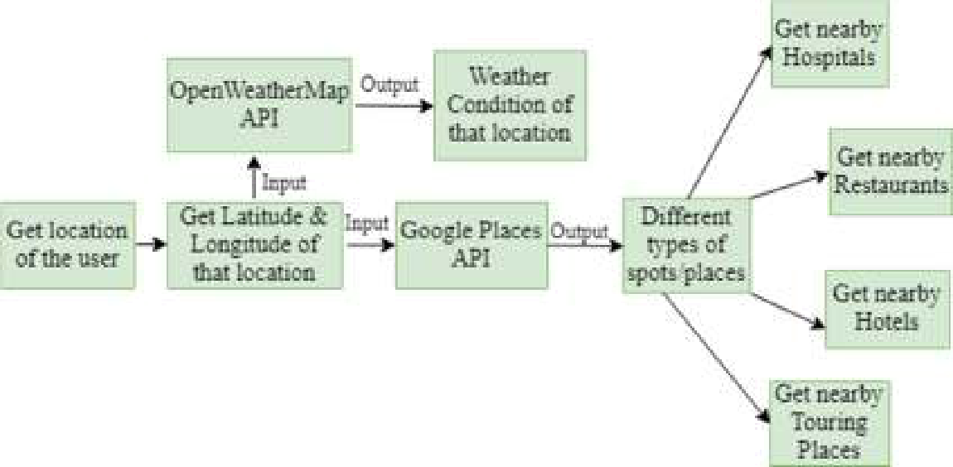

**Figure 6: Exploration process of nearby spots**

**Text recognition Process:**

Another important part of my project is the recognition of text of the description related to uploaded images by the user. Because it will help the blind people in the sense that he/she will get listening the voice of the related content. This feature will be developed using ‘Google Text Recognition Process’ that described in **[7]**. Basically this process is an iterative process in which the whole text are segmented into characters. The each character are then processed to extract some feature of that. Based on this extracted feature the each character are then recognized. When all the characters related to the text are recognized the text itself is recognized. In my project I will use this method for the recognition of text. The following diagram shows a simplified version of this process.

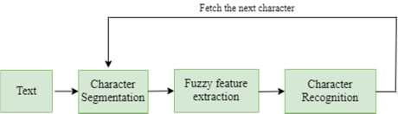

**Figure 7: Text Recognition Process**

15

**5. PROJECT REQUIREMENTS**

**Hardware Requirements:**

* Personal Computer (with Windows 7 or later or Linux Operating System)
* Smartphone (with Android Operating System 4.4.4 or higher)
* Processor (Intel Core i3 or higher)
* Hard Disk (with 20GB of free storage space)
* Memory (2GB RAM)

**Software Requirements:**

* Java SE Development Kit 6 or higher
* Android Studio IDE 2.0.0 or higher
* Android Development Tool (ADT) plug-in
* Adobe XD
* Database
* OpenCV

**Languages:**

* XML (Extensible Markup Language) for Front-end Design.
* Java for Back-end Design.

**Other Requirements:**

* Android Google APIs Key (Google Places, Google Geo-coding, Google Text Recognition)
* OpenWeatherMap.org API key
* Microsoft Sensitive Content Detection API key
* REST (Representational State Transfer) API key

16

1. **DESIGN PROTOTYPE**

Some expected sample design of this project are given below.

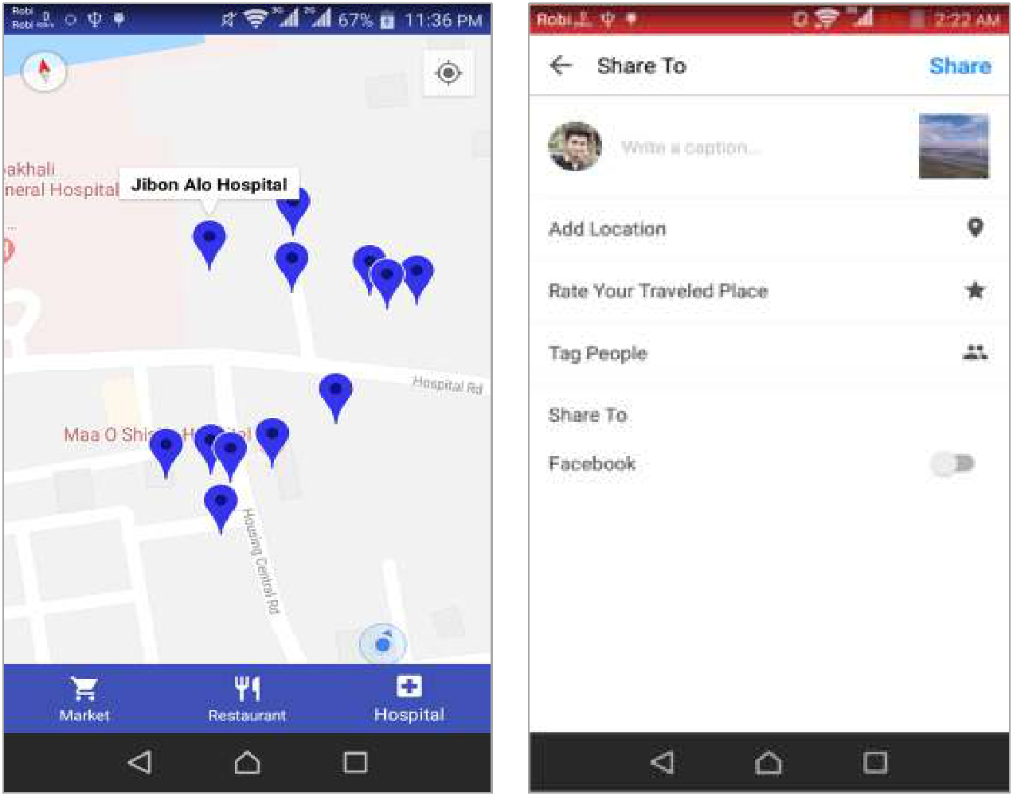

**Figure 8: UI of showing nearby Hospital,** **Figure 9: UI of sharing user’s travelling**

**Restaurant and Market** **experience**

To show the nearby spots like hospitals, restaurants and markets of the user’s location I am expecting the similar User Interface (UI) of the above figure 8. From this UI the user can be able to explore these different types of spots around him separately.

The above figure 9 shows the UI of how the user will share his/her travelling experience. In this UI the user will have to select a picture and write some description of how their visited places was. Also they will have to give a rating of this places. I am expecting such an UI in my project to provide this feature.

17

1. **CONCLUSION AND FUTURE WORKS**

In this paper I proposed to offer an android application that will act as a tourism guide to the travelers. It will provide all the information of nearby spots like hotels, restaurants, hospitals etc. based on a specific location. By using this application the travelers can get the information of weather before making a plan to trip. Besides, this application will also allow them to see traffic condition of a specific location by the visualization of city map. The users of this application can share his/her travelling experience through some description, captured pictures and finally rating of the places. As most of the cases the travelers can’t get the realistic information from the websites that contains the static information about tourist spots, this shared experience will help them to know more detail about the places. In such way, this project will bring a lot of benefit to the travelers. But since the nature of the people is to expect more and more so the following features can also be developed after completing the development of the features that are described in this paper.

* Nearby hotel booking
* Food order from nearby restaurants
* Sharing video of the tourist spots securely
* Integration of Uber to get ride

18

1. **REFERENCES**
2. Manav Singhal, Anupam Shukla, “Implementation of Location based Services in Android using GPS and Web Services” ISSN 1694-0814, Volume 9, Issue 1, No 2, January 2012, International Journal of Computer Science Issues (IJCSI).
3. The Ultimate Transport System, Retrieved (2018, Aug 17) from https://citymapper.com/
4. Travel Social Network, Retrieved (2018, Aug 29) from https://hungrytripper.com
5. A complete Travel Guide which gives an idea about the destination places, Retrieved (2018, Sep 4) from https://www.makemytrip.com/travel-guide/
6. Google Place Photos, Retrieved (2018, Sep 18) from developers.google.com/places/web-service/photos
7. Microsoft Sensitive Content Detection API Key, Retrieved (2018, Sep 26) from docs.microsoft.com/en-us/azure/cognitive-services/content-moderator/image moderation-api
   1. Google Text Recognition API, Retrieved (2018, Oct 2) from firebase.google.com/docs/ml-kit/android/recognize-text
8. Google Geo-coding API converting addresses into geographic coordinates, Retrieved (2018, Oct 7) from developers.google.com/maps/documentation/geocoding
9. Google Places API, Retrieved (2018, Oct 15) from developers.google.com/places/web-service/search
10. Weather Forecast API, Retrieved (2018, Oct 19) from https://openweathermap.org/api
11. Travel Guide Bangladesh–An application based on information of tourist spots, (Retrieved 2018, Oct 21) from play.google.com/store/apps/details?id=app.marszone.travelguide
12. Dadape Jinendra R., Jadhav Bhagyashri R., Gaidhani Pranav Y., Vyavahare Seema U., AchaliyaParag N., “Smart Travel Guide : Application for Android Mobile” ISSN 2277-9477, March 2012, Special Issue of International Journal of electronics, Communication & Soft Computing Science & Engineering.
13. Tourist scope and major tourist spots in Bangladesh, (Retrieved 2018, Oct 29) from http://www.assignmentpoint.com/arts/modern-civilization/tourism-scope-and-major-tourist-spots-in-bangladesh.html

19